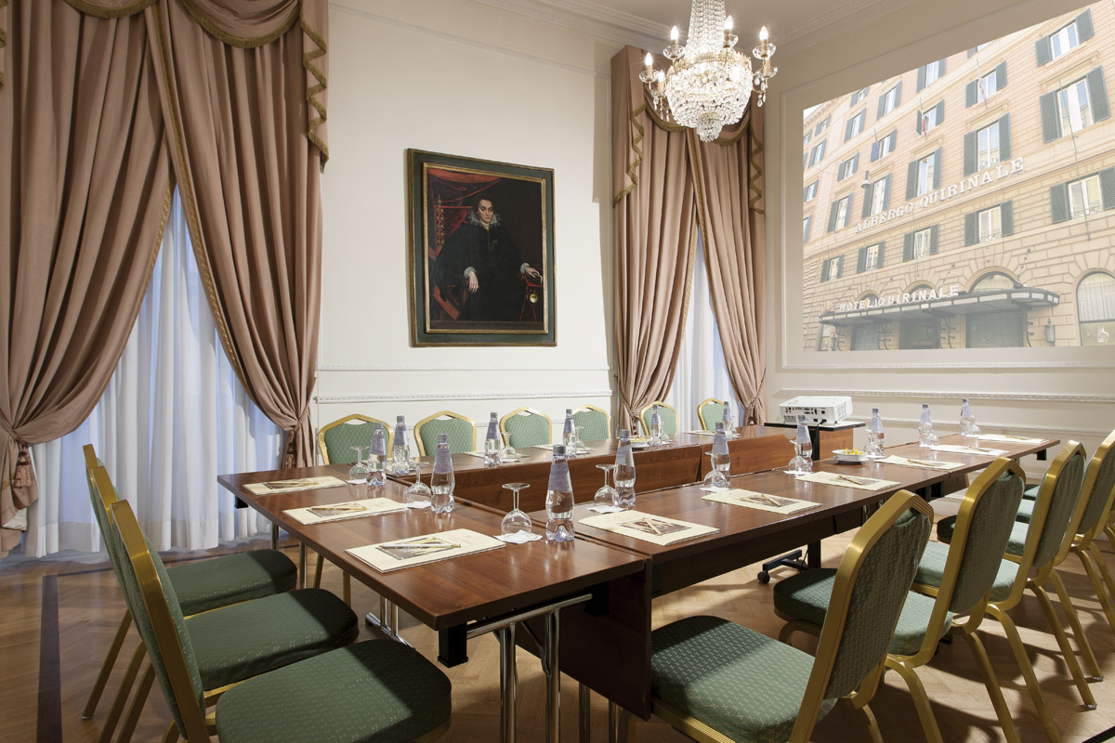
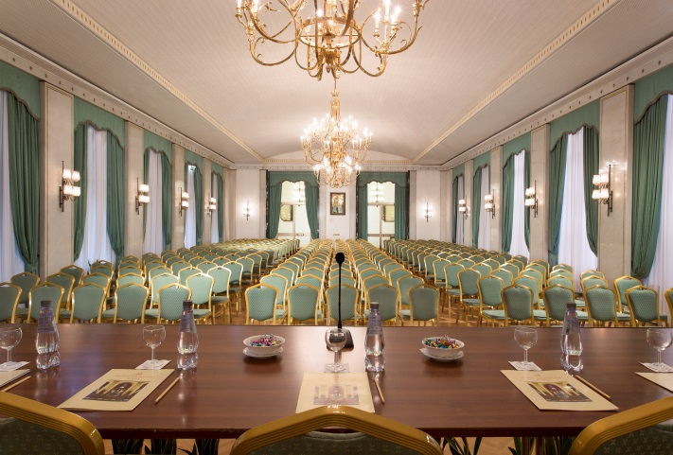

Completely renovated banqueting and conference facilities up to 250 pax –
One Plenary meeting room and four break-out all with natural daylight.
Conventions, meetings and receptions in a welcoming atmosphere – adjoining meeting rooms adaptable to any request with the most advanced technology and professional staff.
The hotel offers an ambience of luxury and refinement and it is also a true heaven of peace and quiet with its private garden, much in demand for parties and wedding receptions, where during the Spring and Summer months, the bar and restaurant can be enjoyed in the shade of a magnificent cedar tree. The history of the Hotel Quirinale is indissolubly linked to the adjoining Opera House, connected to the hotel by a secret passage.
The privacy of the venue renders the hotel the ideal place for every kind of appointment.

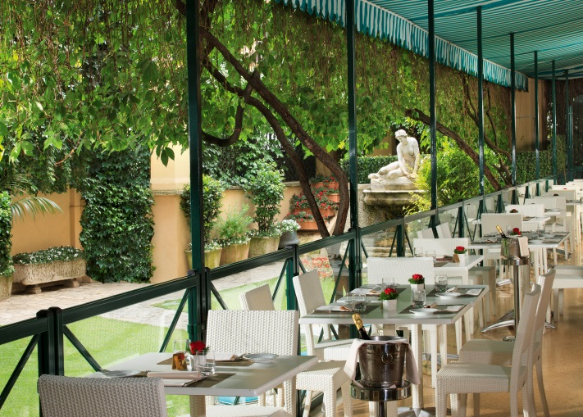
LOCATION
The hotel is in the centre of Rome close
to the major highlights of the Eternal City.
35 km. from Leonardo da Vinci Airport.
400mt from Termini Station

RESTAURANT
rOSSINI RESTAURANT WITH TERRACE ON THEGARDEN
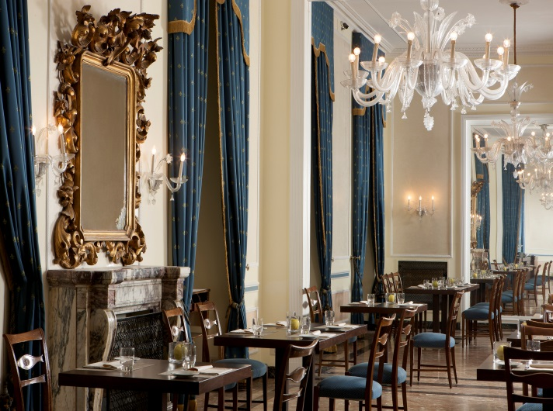

GDS CODES
AMADEUS: WWROMQUI
APOLLO/GALILEO: WW2515
SABRE:WW13100
WORLDSPAN:WWROMQU

Hotel Quirinale - Via Nazionale 7 - 00184 Rome, Italy
Phone +39 06 4707 - Fax +39 06 4820099 - www.hotelquirinale.it - info@hotelquirinale.it

